Dear Parishioners,

I have unfortunately caught Covid and am unable to celebrate the Sunday’s Mass with you this weekend.

The Archdiocese has made it possible for the Celebration of the Word with Communion to take place on a Sunday if this occurred. The Roman Document that governs this possibility is [*‘Sunday Celebrations in the Absence of a Priest’*](https://www.catholic.org.au/acbc-media/downloads/all-downloads/bishops-1/handbook-1/1392-sunday-celebrations-in-the-absence-of-a-priest-may-2010-1/file) outlined in a document published by the Australian Bishops Conference. You will find the document on the Australian Catholic Bishops Conference website. For such a celebration to occur is the exception in times like this not the norm.

I have been unable find a supply priest at such short notice; you may wish to check the Sunday Masses in the surrounding parishes.

Those who will celebrate with you this week are:

*[List Mass times and who the lay leader will be for each Mass.]*

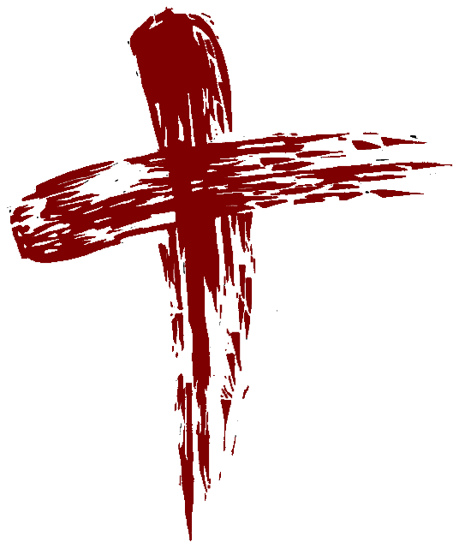

Pray for Me