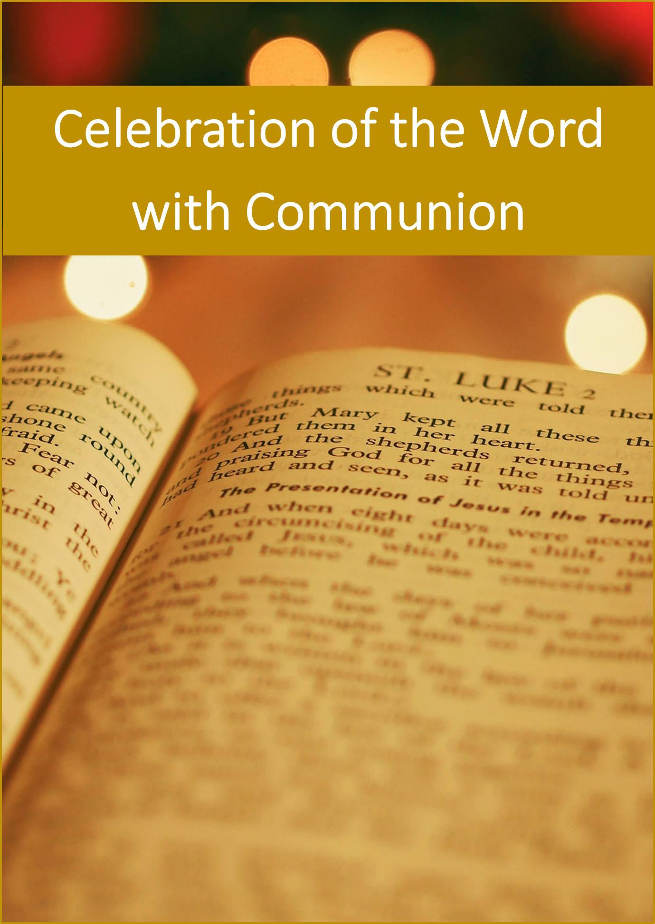

Introductory Rites

Gathering Song

Insert Music Text

Liturgical Greeting

Leader: In the name of the Father, and of the Son, and of the Holy Spirit.

**All: Amen.**

Leader: The grace and peace of God our Father and the Lord Jesus Christ be with us.

Leader: The grace and peace of God our Father and the Lord Jesus Christ be with us.

**All: Blessed be God, the Father of our Lord, Jesus Christ.**

Introductory Remarks

Leader: Since no priest is available today, we cannot celebrate the Eucharist together. Nevertheless, we have gathered to be nourished by God’s word and share Holy Communion.

Opening Rite

Litany of Praise

Leader: Our Saviour is rich in mercy and kindness.

Let us give praise to Christ our Lord.

Leader: Jesus, Word of God, you came to reveal God’s love to us:

Lord, have mercy.

**All: Lord, have mercy.**

Leader: Jesus, risen from the dead, you bring us to new life:

Christ, have mercy.

**All: Christ, have mercy.**

Leader: Jesus, Sun of Justice, you bring together the scattered flock of God:

Lord, have mercy.

**All: Lord, have mercy.**

Leader: May Almighty God have mercy on us, forgive us our sins, and bring us to everlasting life.

**All: Amen.**

**OR**

Penitential Act

Leader: My brothers and sisters,

to prepare ourselves to hear the word of God,

let us call to mind our sins.

**All: I confess to almighty God,**

**and to you, my brothers and sisters,**

**that I have greatly sinned,**

**in my thoughts and in my words,**

**in what I have done,**

**and in what I have failed to do,**

*(and, striking their breast, they say:)*

**through my fault,**

**through my fault,**

**through my most grievous fault;**

**therefore I ask blessed Mary ever-Virgin,**

**all the Angels and Saints,**

**and you, my brothers and sisters,**

**to pray for me to the Lord our God.**

**OR**

Lord Have Mercy / Kyrie - Sung

Leader: Gathered together in Christ, let us sing of God’s mercy and forgiveness.

Insert Text

Opening Prayer

Leader: Let us pray that we will know and do what God wills.

God of love, hear our prayers.

Help us to know your will

and do it with courage and faith.

Grant this through our Lord Jesus Christ,

your Son, who lives and reigns with you

and the Holy Spirit, God, forever and ever.

**All: Amen.**

**OR**

Leader: Let us pray that we will know and do what God wills.

Father,

watch over your family and keep us safe

in your care,

for all our hope is in you.

Grant this through our Lord Jesus Christ,

your Son, who lives and reigns with you

and the Holy Spirit, God, forever and ever.

**All: Amen.**

Liturgy of the Word

First Reading

Insert Reading Reference

Responsorial Psalm

Insert Response to the Psalm

Second Reading

Insert Reading Reference

Gospel Acclamation

Insert Text

Gospel

Insert Reading Reference

Scriptural Reflection

An image may be added that relates to the reflection.

Profession of Faith

Apostles Creed

**All: I believe in God,**

**the Father almighty,**

**Creator of heaven and earth,**

**and in Jesus Christ, his only Son, our Lord,**

***(at the words that follow, up to and including 'the Virgin Mary', all bow)***

**who was conceived by the Holy Spirit,**

**born of the Virgin Mary,**

**suffered under Pontius Pilate,**

**was crucified, died and was buried;**

**he descended into hell;**

**on the third day he rose again from the dead;**

**he ascended into heaven,**

**and is seated at the right hand of God the Father almighty;**

**from there he will come to judge the living and the dead.**

**I believe in the Holy Spirit,**

**the holy catholic Church,**

**the communion of saints,**

**the forgiveness of sins,**

**the resurrection of the body,**

**and life everlasting. Amen.**

**OR**

Nicene Creed

**All: I believe in one God,**

**the Father almighty,**

**maker of heaven and earth,**

**of all things visible and invisible.**

**I believe in one Lord Jesus Christ,**

**the Only Begotten Son of God,**

**born of the Father before all ages.**

**God from God, Light from Light,**

**true God from true God,**

**begotten, not made, consubstantial with the Father;**

**through him all things were made.**

**For us men and for our salvation**

**he came down from heaven,**

***(At the words that follow, up to and including 'and became man', all bow.)***

**and by the Holy Spirit was incarnate of the Virgin Mary,**

**and became man.**

**For our sake he was crucified under Pontius Pilate,**

**he suffered death and was buried,**

**and rose again on the third day**

**in accordance with the Scriptures.**

**He ascended into heaven**

**and is seated at the right hand of the Father.**

**He will come again in glory**

**to judge the living and the dead**

**and his kingdom will have no end.**

**I believe in the Holy Spirit, the Lord, the giver of life,**

**who proceeds from the Father and the Son,**

**who with the Father and the Son is adored and glorified,**

**who has spoken through the prophets.**

**I believe in one, holy, catholic and apostolic Church.**

**I confess one Baptism for the forgiveness of sins**

**and I look forward to the resurrection of the dead**

**and the life of the world to come. Amen.**

General Intercessions

Proclamation of Praise

Prayer of Thanksgiving

Insert Prayer Text

**OR**

Gloria

Leader: Let us praise God.

**All: Glory to God in the highest,**

**and on earth peace to people of good will.**

**We praise you, we bless you,**

**we adore you, we glorify you,**

**we give you thanks**

**for your great glory,**

**Lord God, heavenly King,**

**O God almighty Father.**

**Lord Jesus Christ, Only Begotten Son,**

**Lord God, Lamb of God,**

**Son of the Father,**

**you take away the sins of the world, have mercy on us;**

**you take away the sins of the world, receive our prayer;**

**you are seated at the right hand of the Father,**

**have mercy on us.**

**For you alone are the Holy One, you alone are the Lord,**

**You alone are the Most High, Jesus Christ,**

**with the Holy Spirit, in the Glory of God the Father. Amen.**

Sign of Peace

Leader: Let us offer each other a sign of peace.

Communion Rite

The Lord’s Prayer

Leader: At the Saviour’s command and formed by divine teaching we dare to say:

**All: Our Father…**

Invitation to Communion

Leader: Behold the Lamb of God

behold him who takes away the sins of the world.

Blessed are those called to the supper of the Lamb.

**All: Lord, I am not worthy**

**that you should enter under my roof,**

**but only say the word**

**and my soul shall be healed.**

Prayer after Communion

Leader: Let us pray.

God blessings,

We have been fed at this table with the bread of heaven.

Give us the food always,

That it may strengthen your love in our hearts

And inspire us to serve you in our brothers and sisters.

Grant this in the name of Jesus Christ our Lord.

**All: Amen.**

Concluding Rite

Blessing

Leader: May the God of hope fill us with every joy in believing.

May the peace of Christ abound in our hearts.

May the Holy Spirit enrich us with gifts for service

Now and forever.

**All: Amen.**

**OR**

Leader: May the Lord bless us and keep us.

**All: Amen.**

Leader: May his face shine upon us and be gracious to us.

**All: Amen.**

Leader: May he look upon us with kindness and give us peace.

**All: Amen.**

Leader: May almighty God bless us, the Father, and the Son, and the Holy Spirit.

**All: Amen.**

**OR**

Leader: May the peace of God

which is beyond understanding

keep our hearts and minds

in the knowledge and love of God

and of his Son, our Lord Jesus Christ.

**All: Amen.**

Leader: May almighty God bless us,

the Father, and the Son, and the Holy Spirit.

**All: Amen.**

**OR**

Leader: Let us go in peace to love and serve the Lord.

**All: Thanks be to God.**

Concluding Song

Insert Song text